Name ____________________________
Hr.______
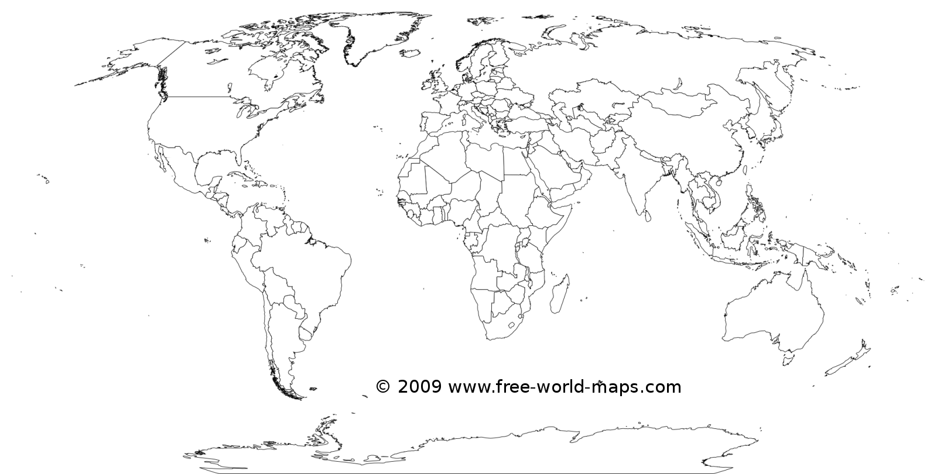
Government Structures around the World

Legend- Label every government structure

